**DAILY ONLINE ACTIVITIES SUMMARY**

|  |  |  |  |  |  |  |  |  |
| --- | --- | --- | --- | --- | --- | --- | --- | --- |
| **Date:** | 04/06/2020 | | | | | **Name:** | Chethan C K | |
| **Sem & Sec** | 4th SEM ‘A’ SEC | | | | | **USN:** | 4AL18CS017 | |
| **Online Test Summary** | | | | | | | | |
| **Subject** | | Microcontroller and Embedded Systems(18CS44) | | | | | | |
| **Max. Marks** | | 20 | | **Score** | | | 15 | |
| **Certification Course Summary** | | | | | | | | |
| **Course** | Face Recognition with Deep Learning using Python | | | | | | | |
| **Certificate Provider** | | | Udemy | | **Duration** | | | 3 Hours |
| **Coding Challenges** | | | | | | | | |
| **Problem Statement:**1. Write a code segment in java to swap two numbers using call by  object reference.   2. Write a Java program to find Last Digit of a^b (a to the power b) for  large numbers. | | | | | | | | |
| **Status:** Completed | | | | | | | | |
| **Uploaded the report in Github** | | | | | YES | | | |
| **If yes Repository name** | | | | | <https://github.com/alvas-education-foundation/chethan_c_k> | | | |
| **Uploaded the report in slack** | | | | | YES | | | |

**Online Test Details:**

The online test was from module 3 which was about Embedded System Components. There were 20 questions of 1 mark each which lasted for 30 minutes. The questions were easy. I scored 15 out of 20.

**Snapshot**:

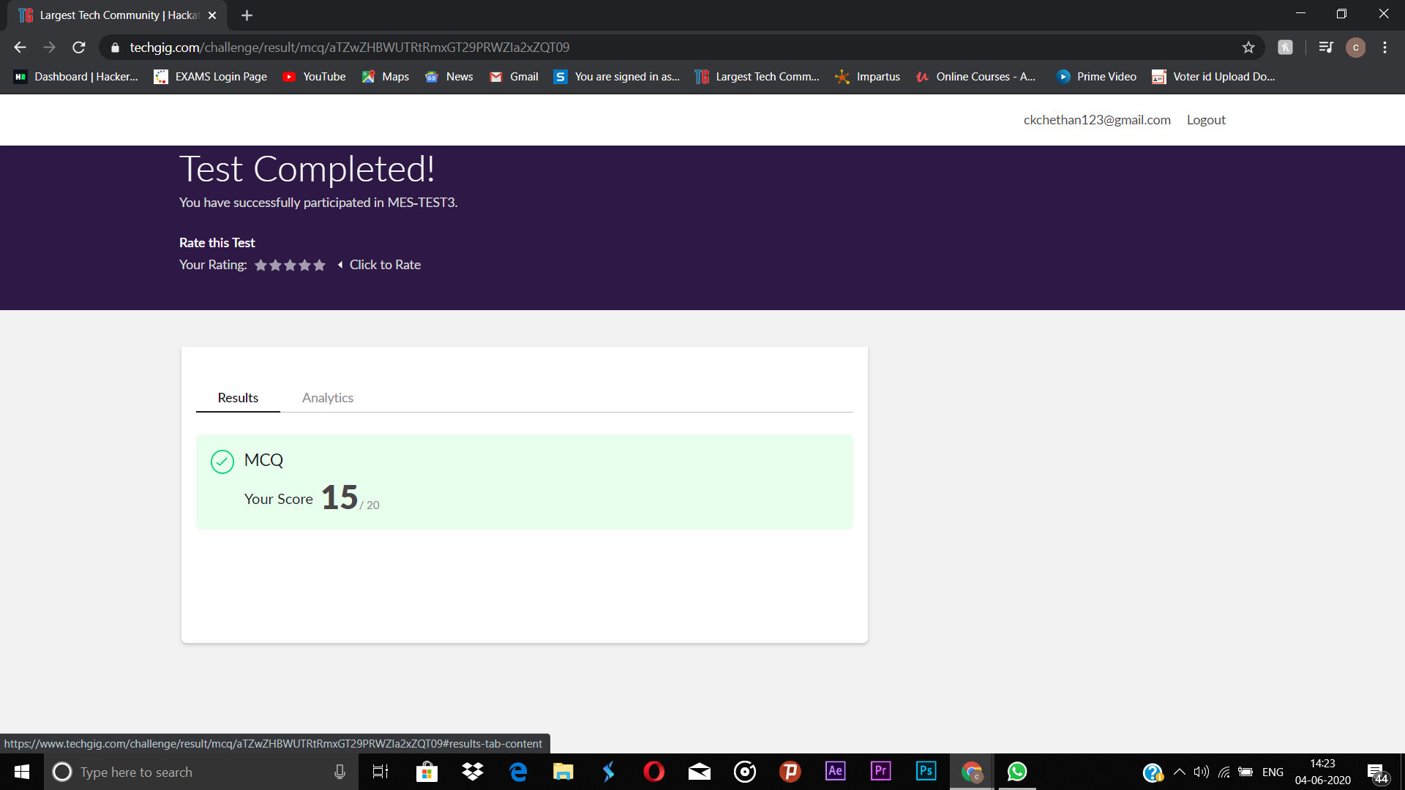

**Certification Course Details:**

**Name of the course**: Face Recognition with Deep Learning using Python

**Certificate Provider**: Udemy

Today I went through the course that explained about Real time application by capturing the image captured from webcam.

**Snapshot:**

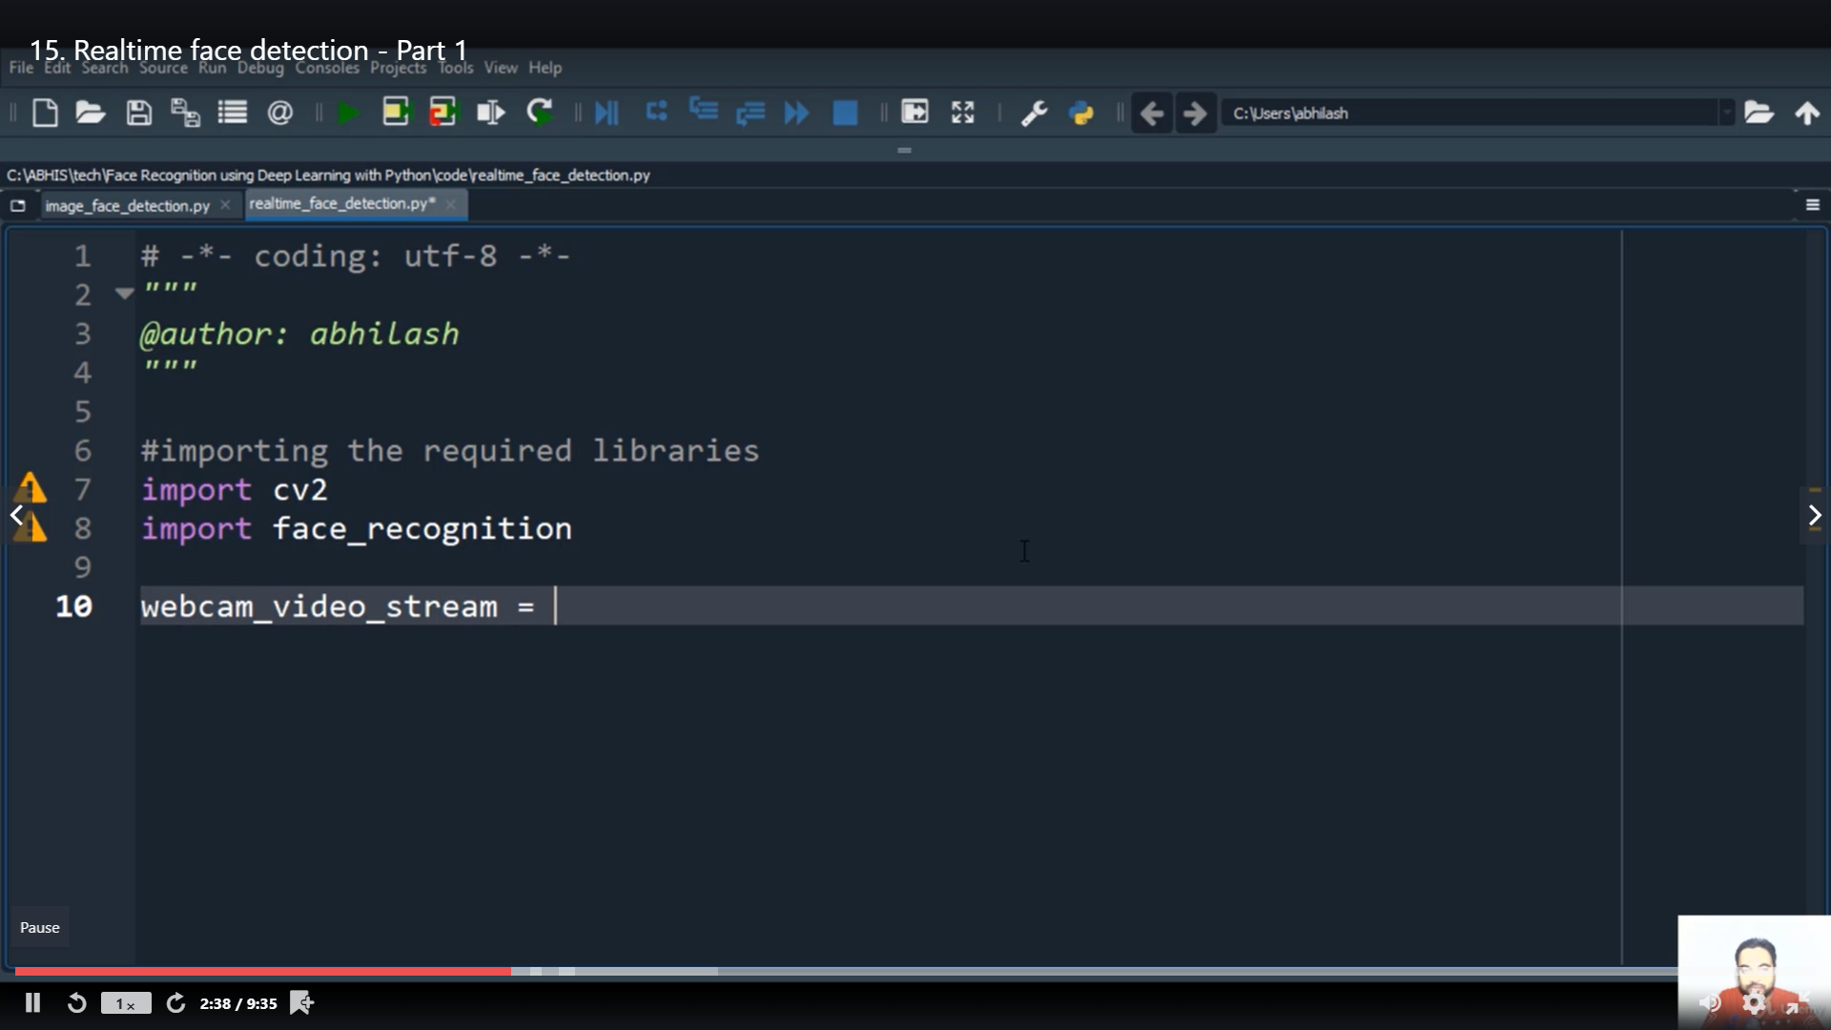

**Online Coding Details:**

Problem 1: Write a code segment in java to swap two numbers using call by object reference.

Output: Process being scheduled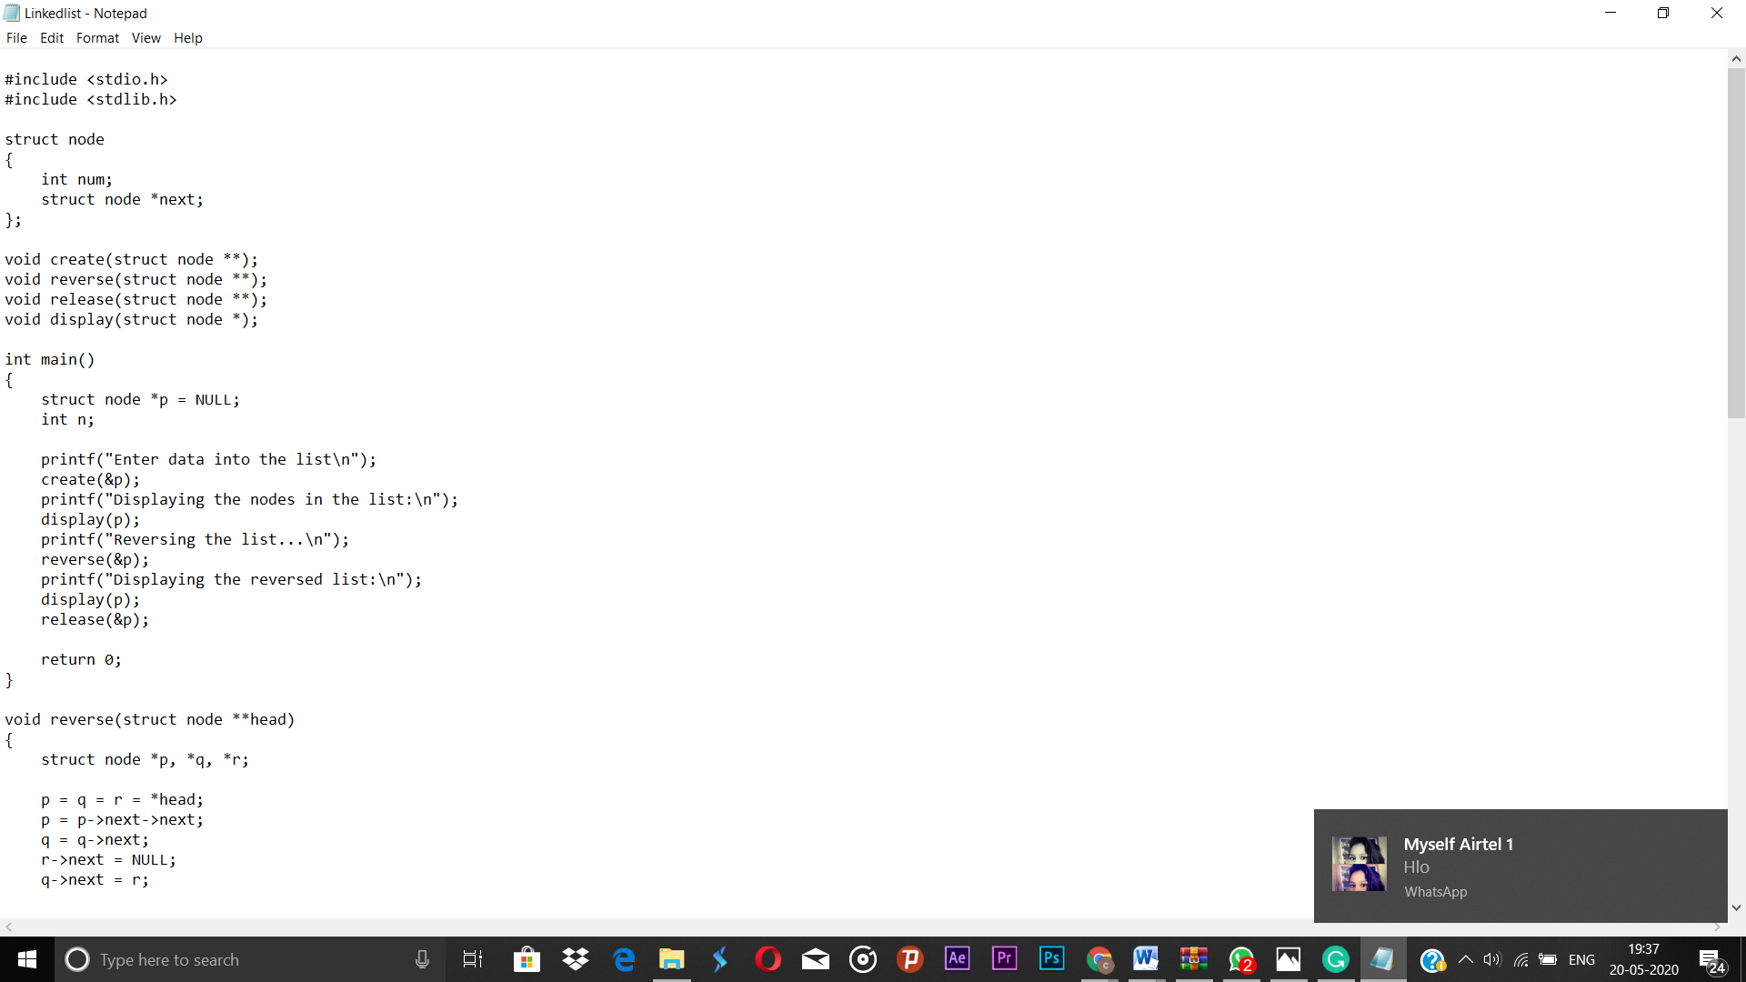Top of Form

Bottom of Form

**Snapshot:**

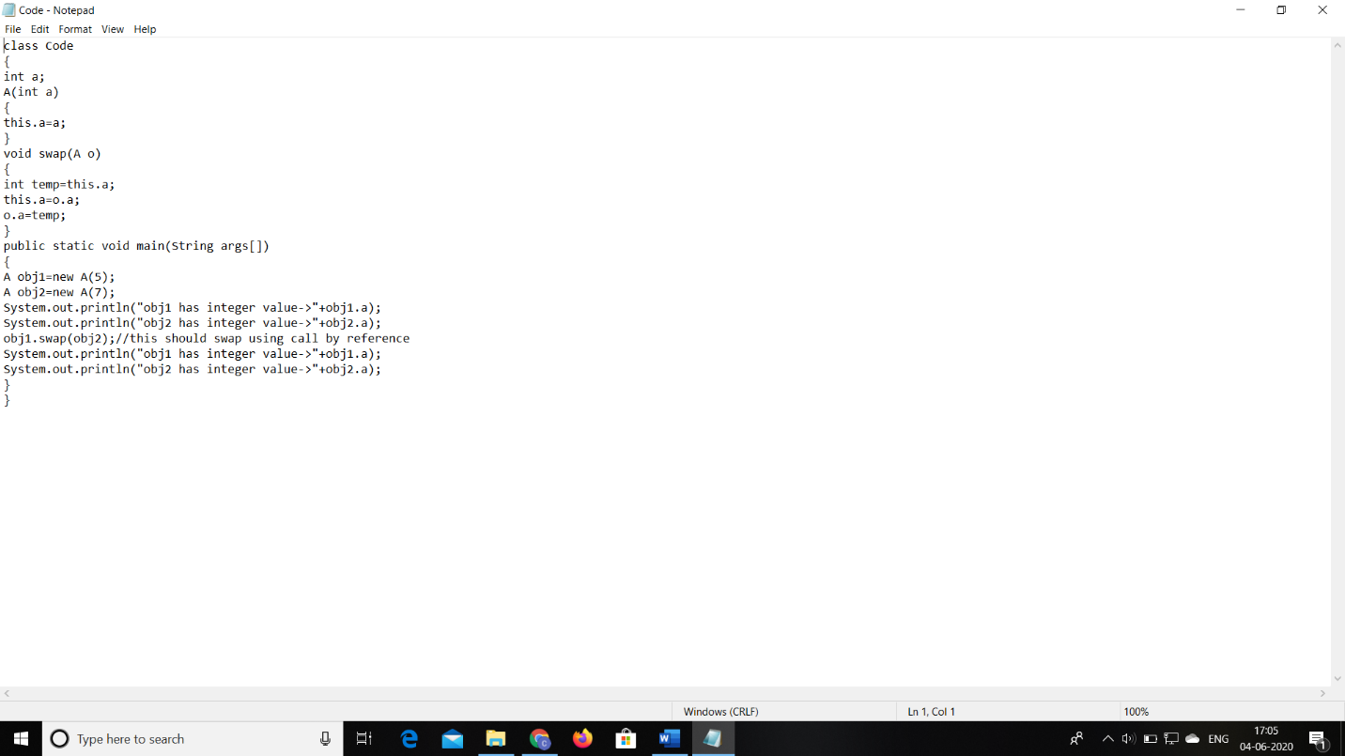

Problem 2: Write a Java program to find Last Digit of a^b (a to the power b) for large numbers.

**Snapshot:**

